**Front-End UI/UX Mini Project**

"Responsive Portfolio Website for My Favorite City Blog"

**• Course: *UI/UX Design Fundamentals*  
• Instructor: *Narendra Kumar*• Institution: *Christ University, Kengeri*  
• Date of Submission: *13/08/2025***

**Submitted By:**

* Hemish Gogineni (2460372) ([hemish.gogineni@btech.christuniversity.in](mailto:hemish.gogineni@btech.christuniversity.in))
* Joel Biju Kainikat (2460379) ([joelbijukainikat@btech.christuniversity.in](mailto:joelbijukainikat@btech.christuniversity.in))
* Mathew Thomas (2460405) ([mathew.thomas@btech.christuniversity.in](mailto:mathew.thomas@btech.christuniversity.in))

**2. Abstract**

This project focuses on designing and developing a responsive portfolio website dedicated to showcasing the beauty, culture, and attractions of my favorite city. The primary goal is to create an engaging, user-friendly platform that dynamically presents information such as local landmarks, events, travel tips, and photo galleries. Core technologies utilized include HTML5 and CSS3 to ensure responsiveness across devices and smooth user interaction. The final outcome is a visually appealing, easy-to-navigate website that adapts seamlessly to different screen sizes, offering visitors quick access to curated city highlights. This project demonstrates effective use of modern web development practices to enhance storytelling, visual presentation, and information accessibility.

**3. Objectives**

* Design a visually appealing and user-friendly interface following modern UI/UX principles to highlight the city’s unique charm.
* Develop a fully responsive layout that adapts seamlessly to desktop, tablet, and mobile devices.
* Implement structured and semantic HTML5 elements for better accessibility and SEO optimization.
* Apply CSS styling for consistent branding, layout control, and responsive behavior.
* Organize city-related content—such as landmarks, events, travel tips, and cultural highlights—in a clean and engaging format.
* Ensure readability, accessibility, and intuitive navigation for users across all supported devices

**4. Scope of the Project**

* Focuses primarily on front-end development, emphasizing responsive design and UI presentation.
* Uses HTML5, CSS3 only—without server-side technologies or back-end integration.
* Designed to support multiple screen sizes including desktop, tablet, and mobile viewports.
* Relies solely on open-source tools and pure code, avoiding external libraries and frameworks.
* Does not include features like user login, database connectivity, or real-time data fetching.

**5. Tools & Technologies Used**

|  |  |
| --- | --- |
| Tool / Technology | Purpose |
| HTML5 | Markup and content structure |
| CSS3 | Styling and layout management |
| VS Code | Code editor |
| Chrome DevTools | Testing and debugging |

**6. HTML Structure Overview**

* Utilized semantic HTML5 tags such as <header>, <nav>, <main>, <section>, and <footer> for clear content organization and improved accessibility.
* The page is structured into reusable sections including About, Movie Info, and Contact.
* Navigation menu implemented with an unordered list (<ul>) and anchor links to enable smooth scrolling between sections.

**7. CSS Styling Strategy**

* Styling managed through an external CSS file (style.css) for maintainability.
* CSS code organized with comments and clear sections for easier navigation and updates.
* Key techniques used:
  + Flexbox and Grid layout systems for responsive and flexible page design.
  + Media Queries to ensure the website adapts seamlessly across various device sizes.
  + CSS Variables for easy theme customization and consistent styling.
  + Hover effects and smooth transitions to enhance user interaction feedback.

**8. Key Features**

|  |  |
| --- | --- |
| Feature | Description |
| Responsive Design | Website adapts seamlessly to various screen sizes including desktop, tablet, and mobile devices. |
| Smooth Navigation | Fixed top navigation bar with anchor links for easy and smooth scrolling between sections. |
| Project Cards | Movie info displayed in flexible card layouts using Flexbox, with interactive hover effects for better engagement. |
| Contact Form (non-functional) | A placeholder contacts form layout with input fields and submit button for future functionality. |
| Accessible Fonts & Colors | Use of high-contrast colors and readable typography to ensure accessibility for all users. |

**9. Challenges Faced & Solutions**

|  |  |
| --- | --- |
| Challenge | Solution |
| Overlapping elements on small screens | Used media queries to adjust layout and stack elements vertically. |
| Difficulty aligning items using float | Replaced floats with Flexbox and CSS Grid for easier, more reliable alignment. |
| Typography scaling issue | Switched to relative units (em and rem) instead of fixed pixels to improve scalability across devices. |

**10. Outcome**

* Achieved a clean, consistent, and visually engaging front-end layout that effectively showcases city highlights, attractions, and cultural insights.
* All key components, including responsive design and navigation, function smoothly using only HTML and CSS.
* Gained in-depth understanding of responsive layouts, semantic structure, and visual hierarchy tailored for blog-style content presentation.

**11. Future Enhancements**

* Incorporate JavaScript to enable interactivity such as comment sections, search functionality, and dynamic content updates.
* Add animations and transitions to create a more immersive browsing experience.
* Implement backend integration to support content management and user submissions.
* Introduce a theme toggler feature to switch between light and dark modes for improved accessibility and personalization.

**12. Sample Code**

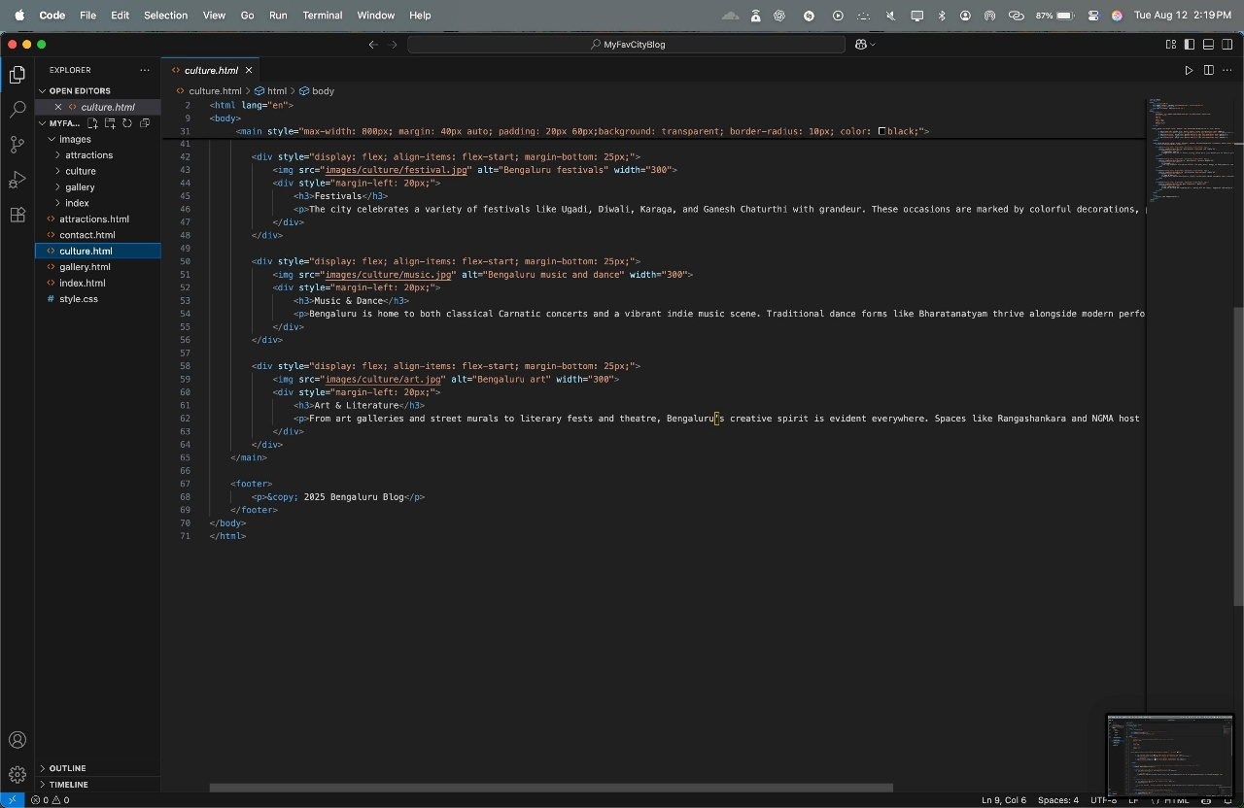

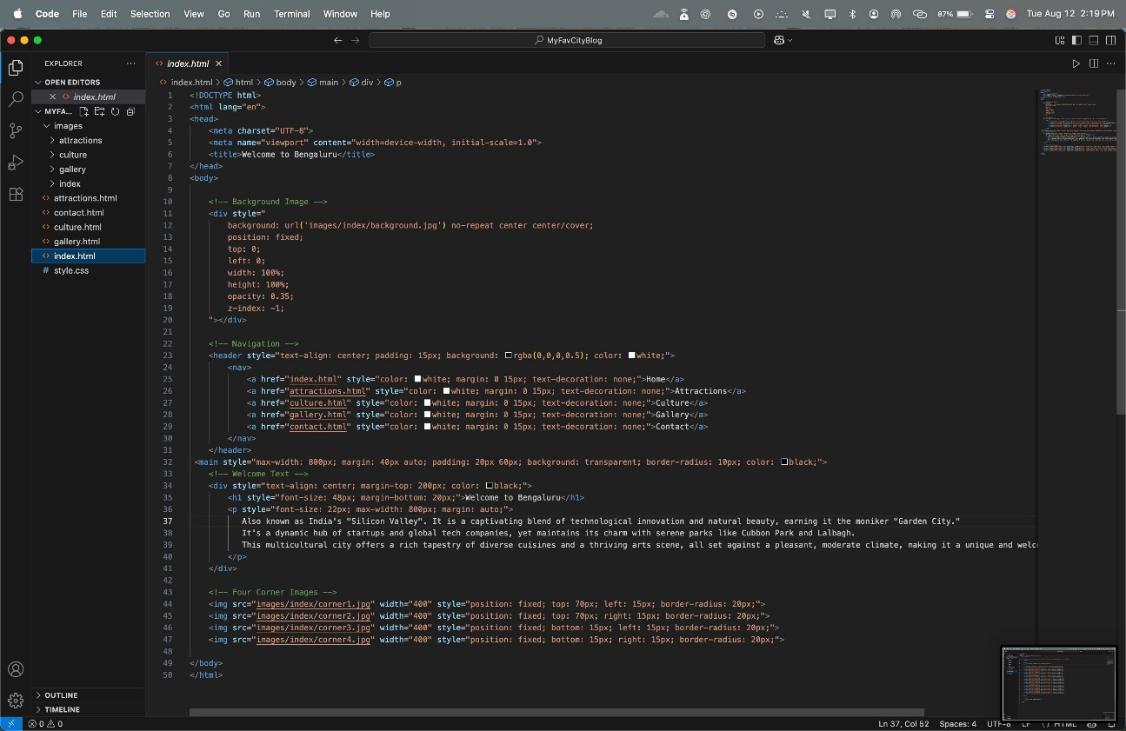

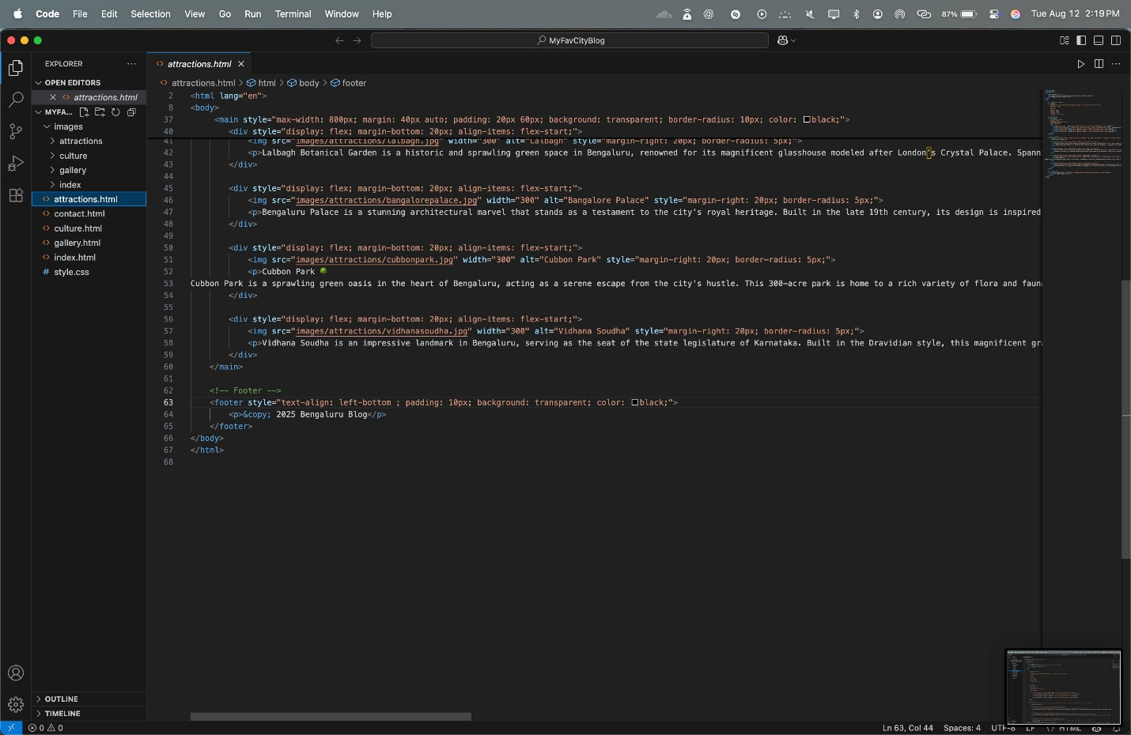

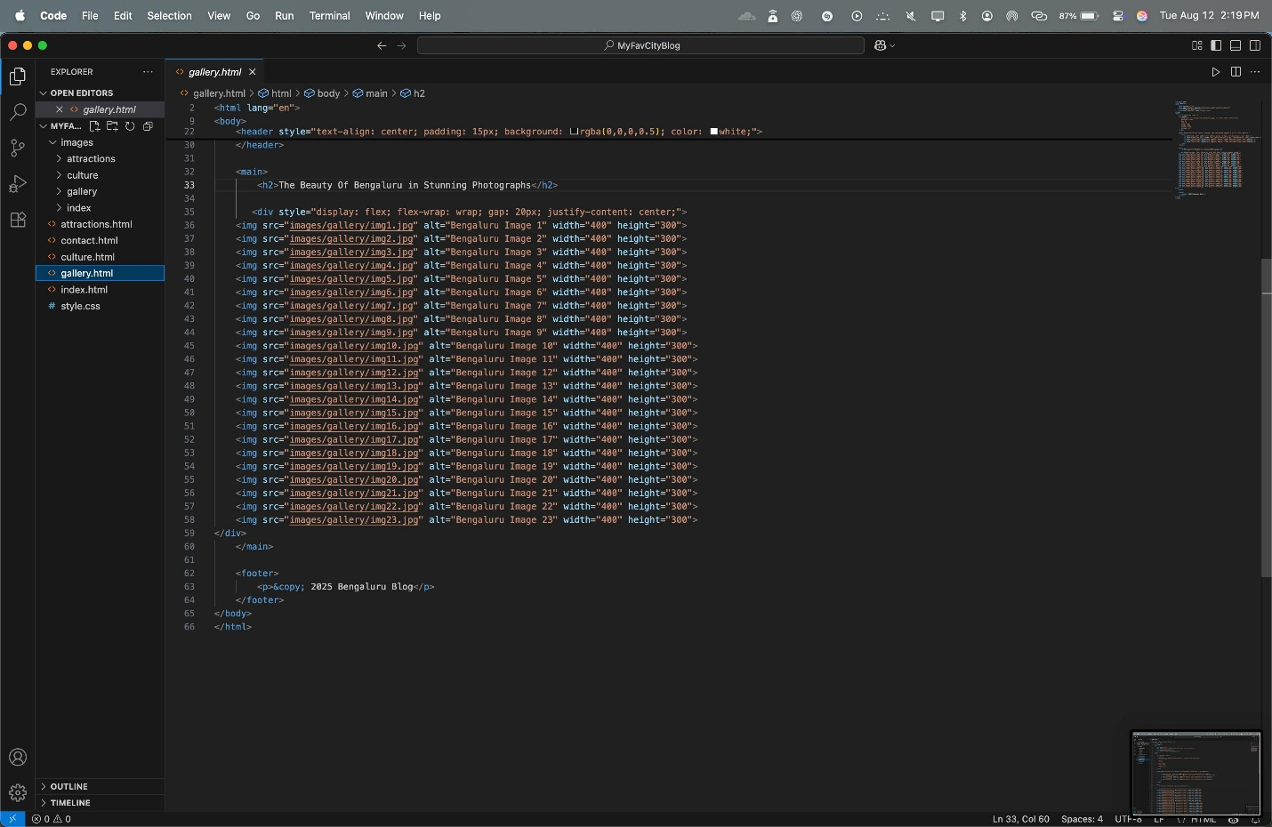

**13. Screenshots of Final Output**

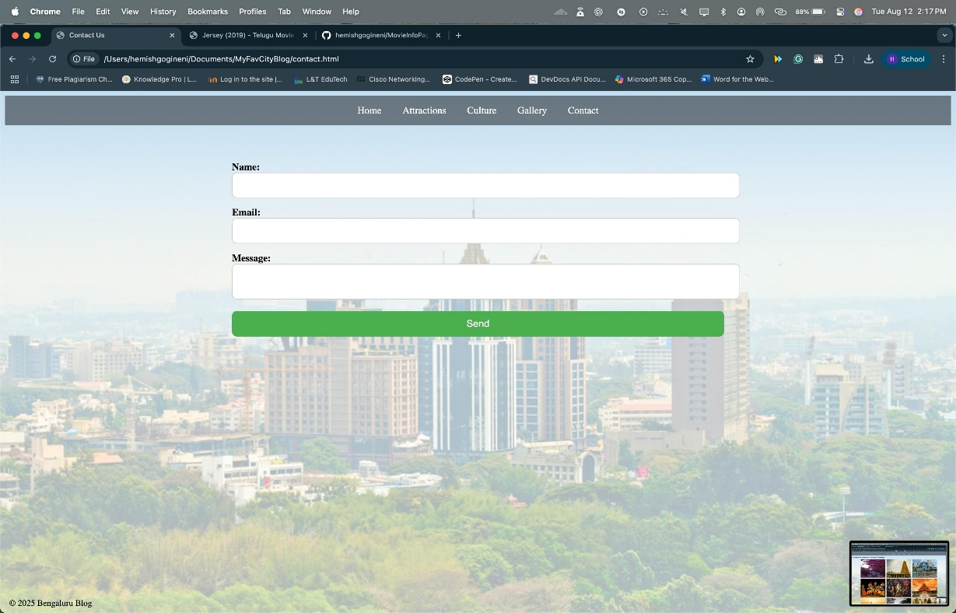

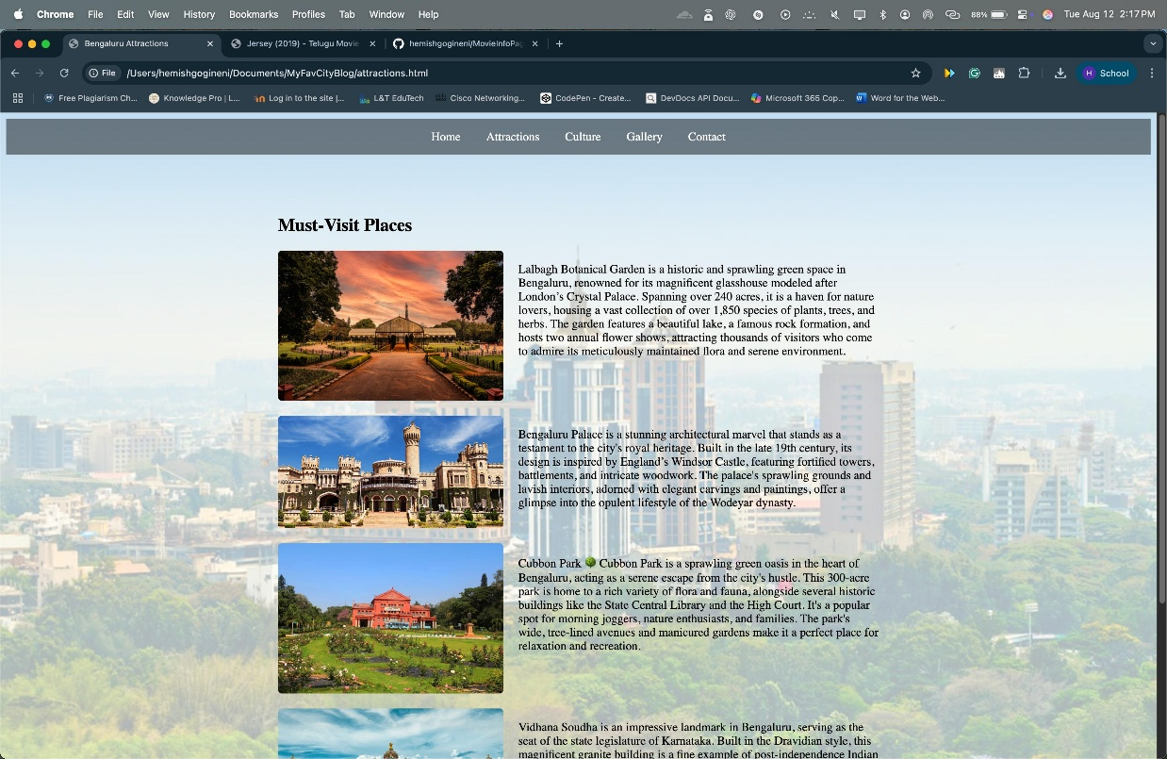

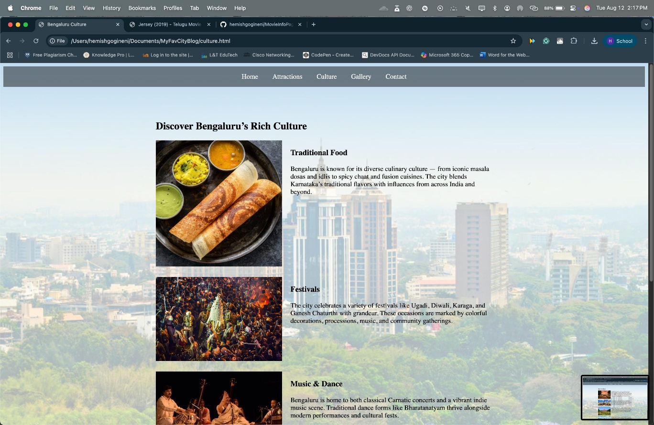

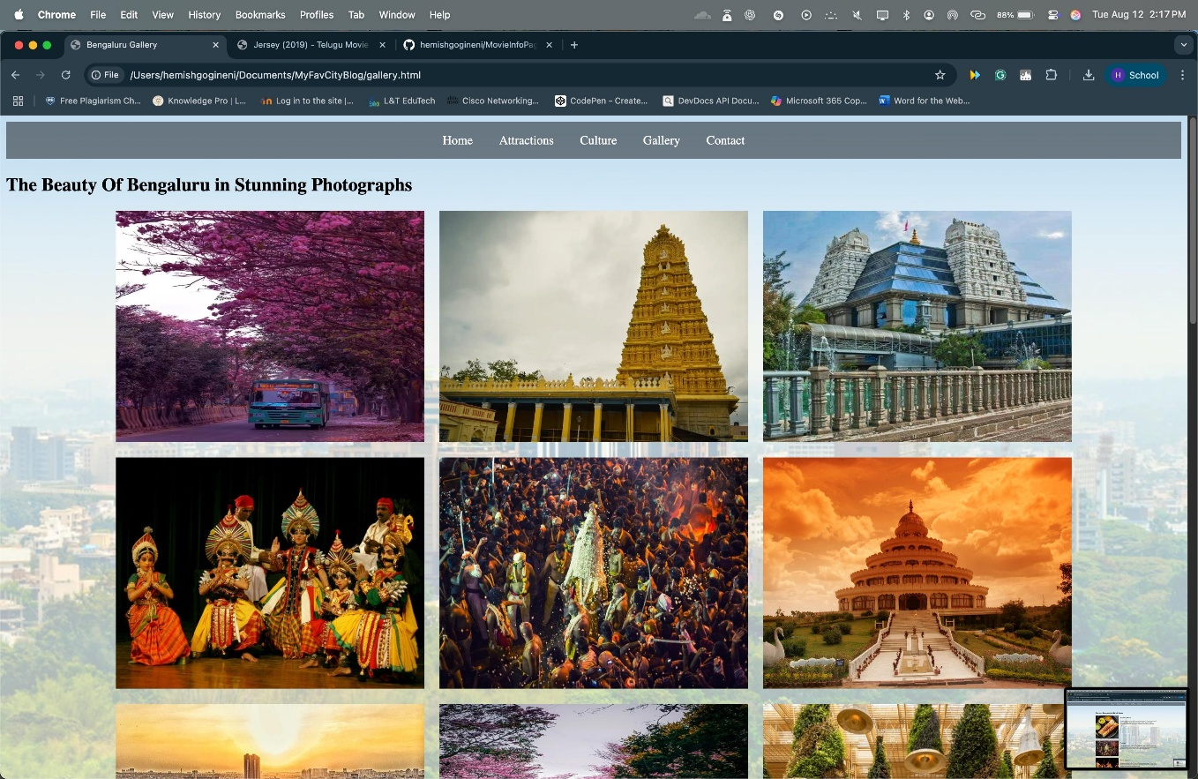

**14. Conclusion**

This project is a responsive blog website dedicated to showcasing the unique charm, culture, and attractions of my favorite city through an engaging and visually appealing interface. Building this site enhanced my front-end development skills using HTML and CSS concepts. I gained practical experience in crafting responsive layouts, organizing content with semantic HTML, and designing user-friendly aesthetics that highlight the city’s character. The hands-on process strengthened my grasp of responsive design principles and user-focused web development, equipping me for future projects that incorporate richer interactivity and backend functionality.

**15. References**

* L&T LMS: <https://learn.lntedutech.com/Landing/MyCourse>
* W3 Schools: <https://www.w3schools.com/html/html_intro.asp>
* W3 Schools: <https://www.w3schools.com/css/css_intro.asp>

*************************************************************************************